# Rotate Kernel – CLI 1 60 lena_512x512_32bit.png lena_512x512_32bit

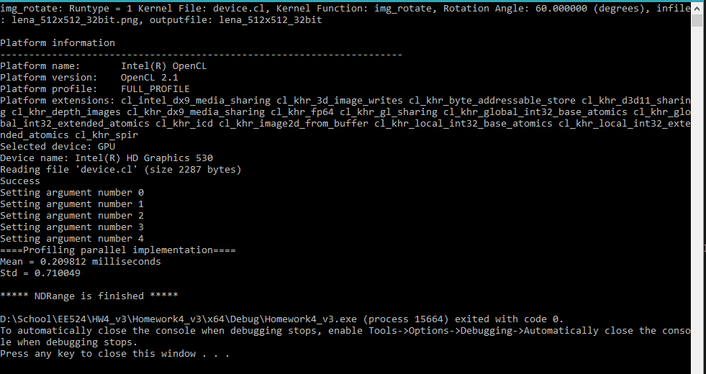

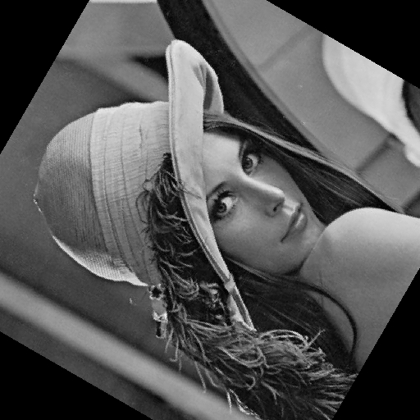

# Blur Kernel – CLI 2 60 lena_512x512_32bit.png lena_512x512_32bit

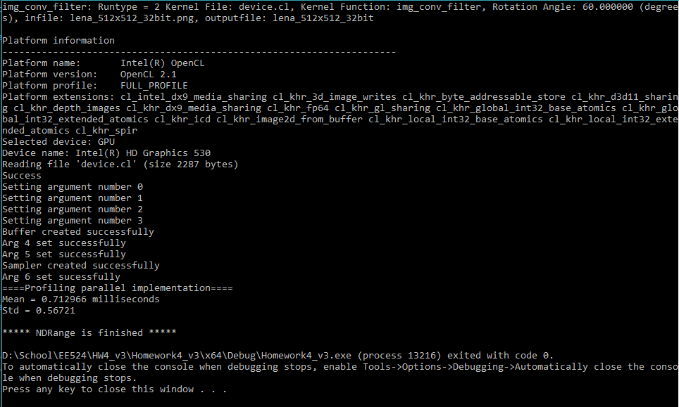

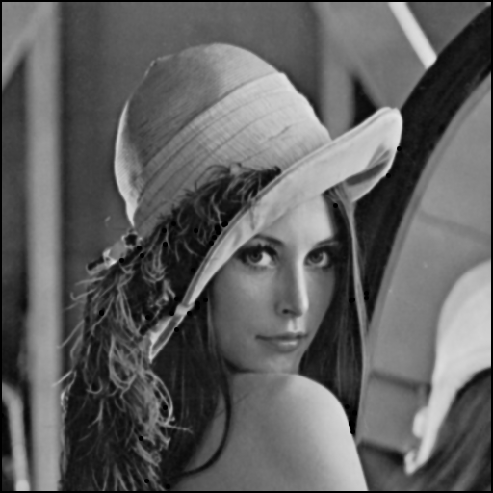

# Parallel vs serial

### lena_512x512_32bit



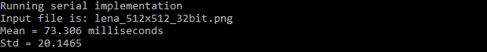

### Big_Gray-Lena_8bit



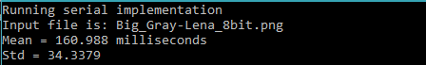

### tiny-Lena_32bit



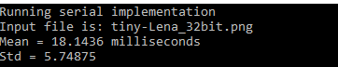

### little-Lena_24bit



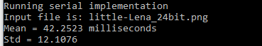

# Parallel vs Serial execution times

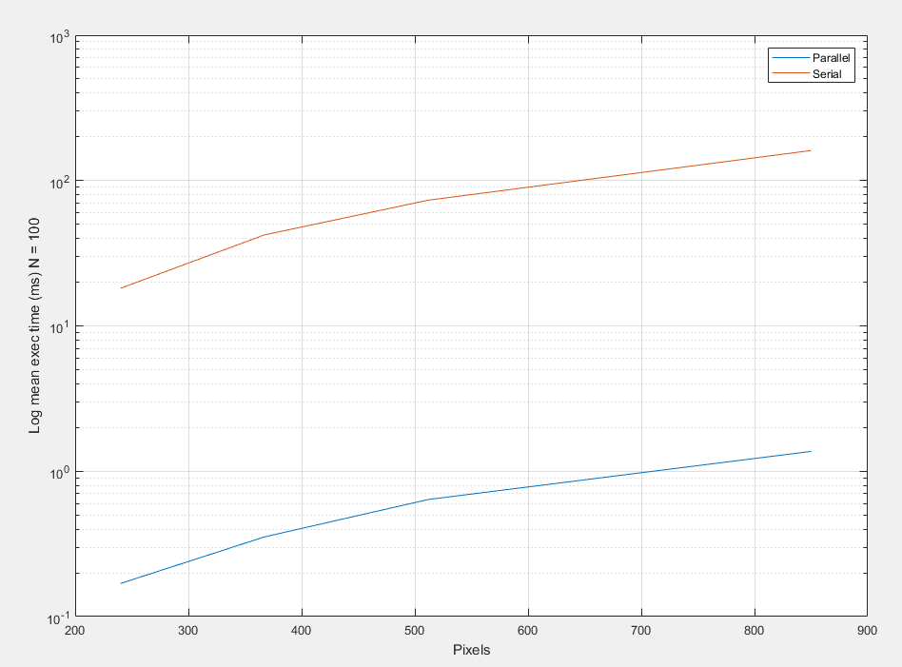

# Blur filters for 5-, 7-, and 9-wide kernels

### 5x5



### 7x7



### 9x9



# Operational Intensity

For an N*N image and an M*M kernel:

Assuming large N, M., edge cases are negligible

For N^2 pixels, do M^2 multiplies and M^2 – 1 adds:

$$N^{2}*2M^{2}-1$$

For memory operations, the kernel must be read once, and the image must be read once and written once:

$$2N^{2}+M^{2}$$

The OpI is

$$\frac{N^{2}*2M^{2}-1}{2N^{2}-M^{2}}$$